SPRINT 04

Iterators
- An object that lets you go through values one by one i.e traversing
- Uses __iter__() to get/return the iterator
- Uses __next__() to get the next value
- Iterable vs Iterator
- Iterable – an object whose values can be gone through one by one like: list, tuple, dictionary, set
- Iterator – an object that actually keeps the track of where we are and gives the next value using next()
- For loop internally uses iterators to move through collections/iterables
- Strings are iterable objects too
- StopIteration tells python “there are no more values, stop the iteration”
We use it in “__next__()” with a condition to stop the iterator after a certain number of values.

Dates
- Not a data type but we can import a module named “datetime” to work with dates as date objects
- Datetime – a module
- Date, time – classes inside that module
- So, datetime.date and datetime.time means access the date and time classes from the datetime module respectively

Math
- Python provides several built-in mathematical functions that works directly with numbers; no need to import anything to use them
- Python also has a built-in module called math, which extends the list of mathematical functions, to use it, import math module
- Common built-in math functions
- Abs() – returns absolute (positive) value
- Pow() – returns num^pow
- Round() – rounds a number
- Min() – smallest value
- Max() – largest value
- Sum() – adds values
- Divmod() – returns quotient and remainder
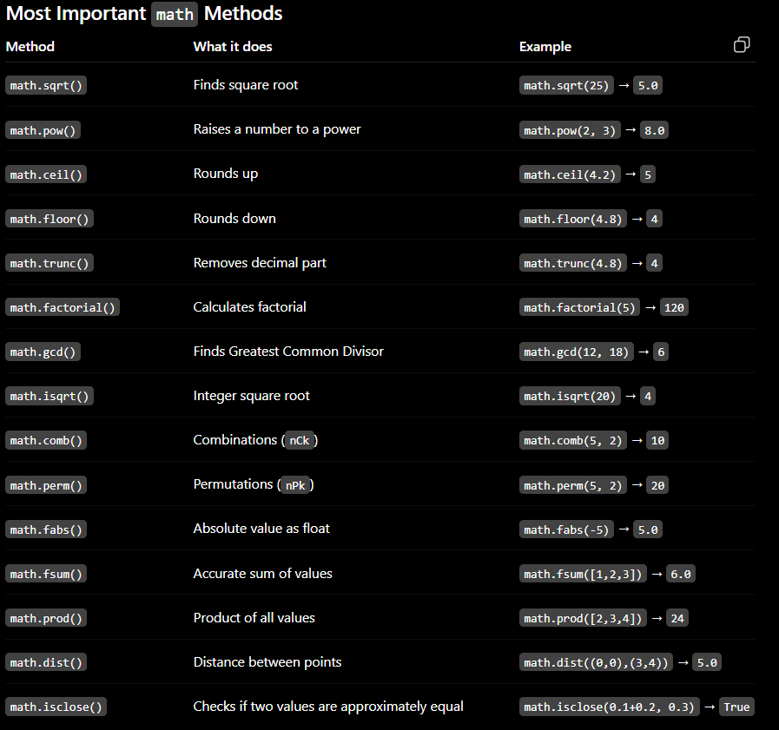

JSON
- Stands for “JavaScript Object Notation”
- Text based format used to store and exchange data
- Is language independent – python, js, java, c++ etc can work with it too
- Json data is written in key-value structure, similar to python dictionaries
- Python provides a built-in json module to work with json
- Python strings can use ‘’ or “” quotes both
- Json strings must use “” ONLY
- We cannot directly access json data using dictionary style keys, we need to parse the json first to convert it into a python object (usually a dictionary).
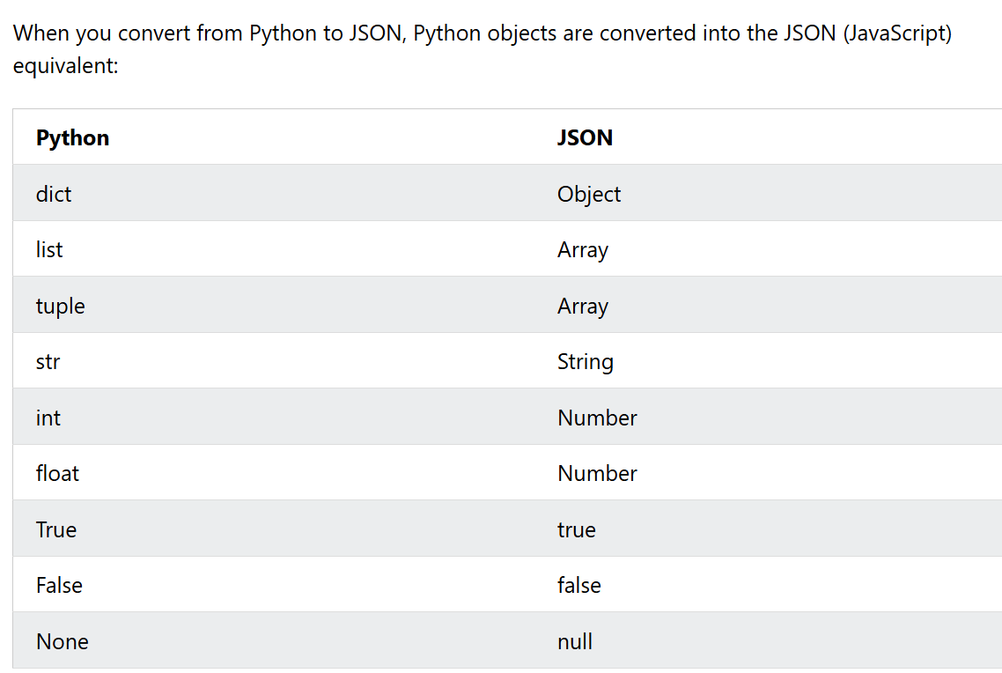

So, Python and JSON use different names/syntax for similar types of data.

- Formatting json with json.dumps()
- Indent – adds spaces and line breaks to make json readable
- Separators – changes how key-value pairs are separated
- Sort_keys() – sorts dict/obj keys alphabetically

Regex
- Is a pattern made of characters, and symbols that is used to search, match, find or validate specific patterns in text
- In simple words, it’s a way of telling python what kind of text pattern are we looking for
- Need of regex?
- Search for specific pattern inside a string
- Check whether the text follows a particular format
- Finds specific parts of a larger text
- Extract matching pieces of information from text
- Replace text that matches a particular pattern
- Validate user input according to a required pattern
Without regex we’d have to manually check through the characters and conditions
- Python provides a built in ‘re’ module for working with regular expressions
- 4 main regex functions
- Re.findall() – finds all matches; returns a list
- Re.search() – finds the first match; match object/none
- Re.split() – splits at matches; returns list
- Re.sub() – replaces matches; returns string
- Re.fullmatch() – requires the pattern to match the entire string from start to finish
- Meta characters
- ‘*’ – zero or more occurrences of
- ‘+’ – one or more occurrences of
- ‘?’ – at most 1 occurrence
- ‘{}’ – use curly braces to specify an exact count; can also be used to specify the range
- ‘.’ – includes all characters
- ‘$’ – ends with; must be placed at last

- Special sequences
- ‘\b’ – the word boundary anchor, ensures that the word is a complete word and not a part of bigger word, while matching words in a string
- ‘\w’ – used for matching characters, digits etc

Modules
- A python file containing reusable code
- Can contain: functions, variables, classes, other python code
- Need?
- Write code once and reuse it multiple times
- Avoid rewriting same functions
- Divide larger program into smaller files
- Smaller modules are easier to find and fix
- Different people can work on different modules
- Can import a module into another python program
- Creating a module
- Create a python file
- Write functions/code inside it
- Save it
- Then import it whenever needed
- Syntax :
Modulename.functionname

